**Wonder Of World**

*User Guide*

|  |  |  |
| --- | --- | --- |
| **Supervisor.** | **Miss Nashmia** | |
| **Batch.** | 2305F1 | |
| **Group.** | C | |
| **Serial No.** | **Enrollment Number** | **Student Name** |
| 1. | 1471131 | Ejlal Ahmed Baloch |
| 2. | 1470389 | Sehrish |
| 3. | 1465469 | Mustajab Ahmed |

1. **Home** (*index.html*)

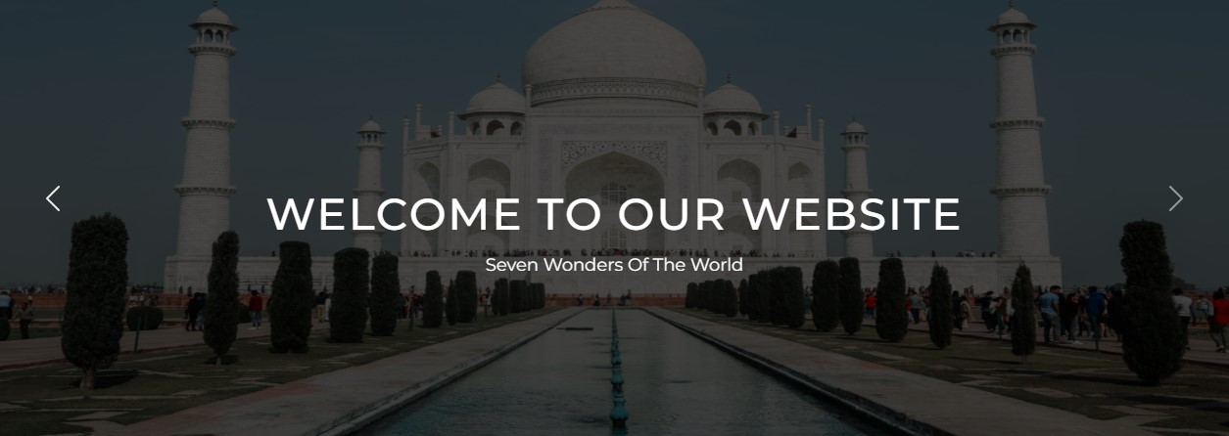

***Figure 1: Home page to WOW***

 The website’s home page has a dynamic carousel displaying images of world wonders.

 Each image comes with a brief overview of the website’s content and purpose. This cool feature is meant to grab visitors’ attention and give them a quick idea of what the website is all about – exploring these incredible places around the world.

1. **Navbar (index .html)**

**

***Figure 2: Navbar***

We have given seven essentials. By clicking any of the essential’s and redirect to the linked page. (0. index .html)

1. **About us (index .html)**



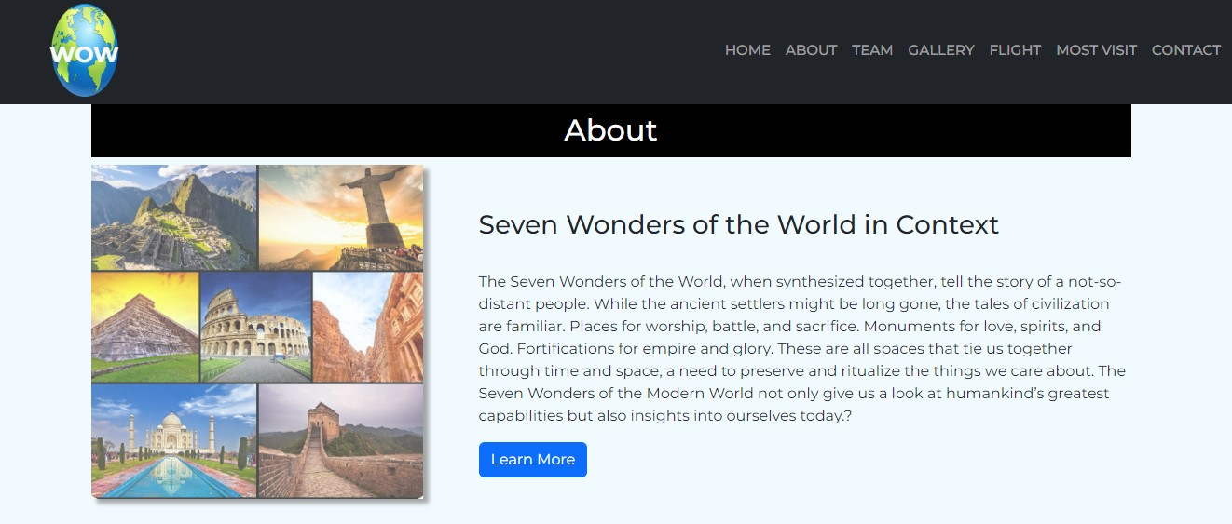

 ***Figure 3: About us***

**

* In the ‘About Us’ section of the website, you can find information about the wonders of world. There is a button ‘Learn More’. When you click on it, a new page opens up with detailed historical information. You can download the history of specific wonders from this page.*

***History (history.html)***

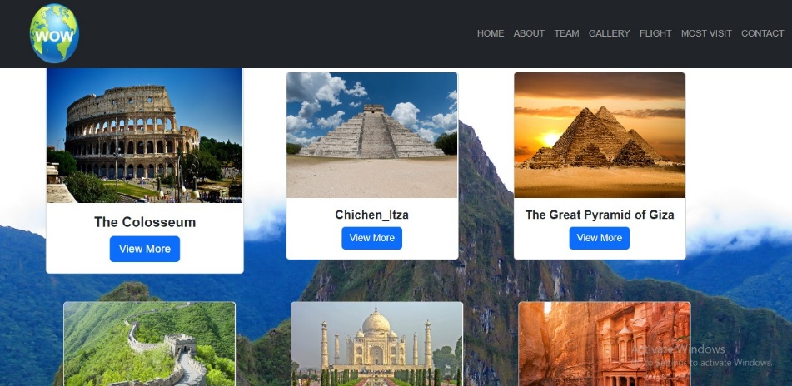

1. ***Menu bar:***



***Figure 4: Description of our Menu bar***

***Use to load the remaining sections. The following is a list of those sections:***

*As we have work on only single page and re-directing on other sections. So we are made our web directed pages.*

* ***Home Page (1. index.html)***
* ***About Page (2. index.html- About Section)***
* ***Team Page (3. index.html-Team Section)***
* ***Gallery Page (4. Gallery.html-Gallery Page)***

*Portfolio details (5. Pagination.html)*

*Portfolio details (6.Pagination-2.html)*

*Portfolio details (7. Pagination -3.html)*

*Portfolio details (8. Pagination -4.html)*

*Portfolio details (9. Pagination -5.html)*

*Portfolio details (10. Pagination-6 html)*

*Portfolio details (11. Pagination -7.html)*

*Portfolio details (12. Pagination-8.html)*

* ***Visit Page (13. index .html -Most visit Section)***
* ***Contact Page (14. Contact.html)***
* ***History page (15.history.html link by About Section)***

1. ***pagination(.html):***

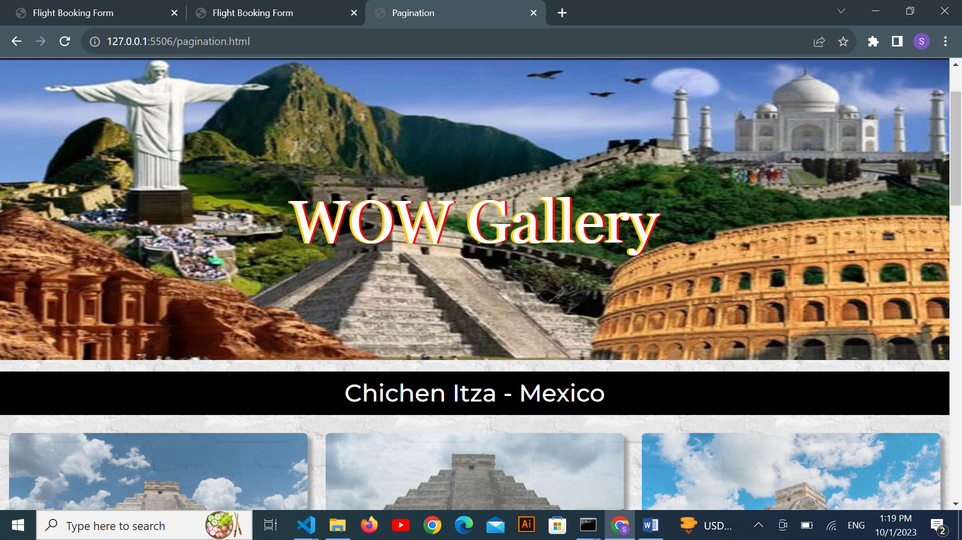

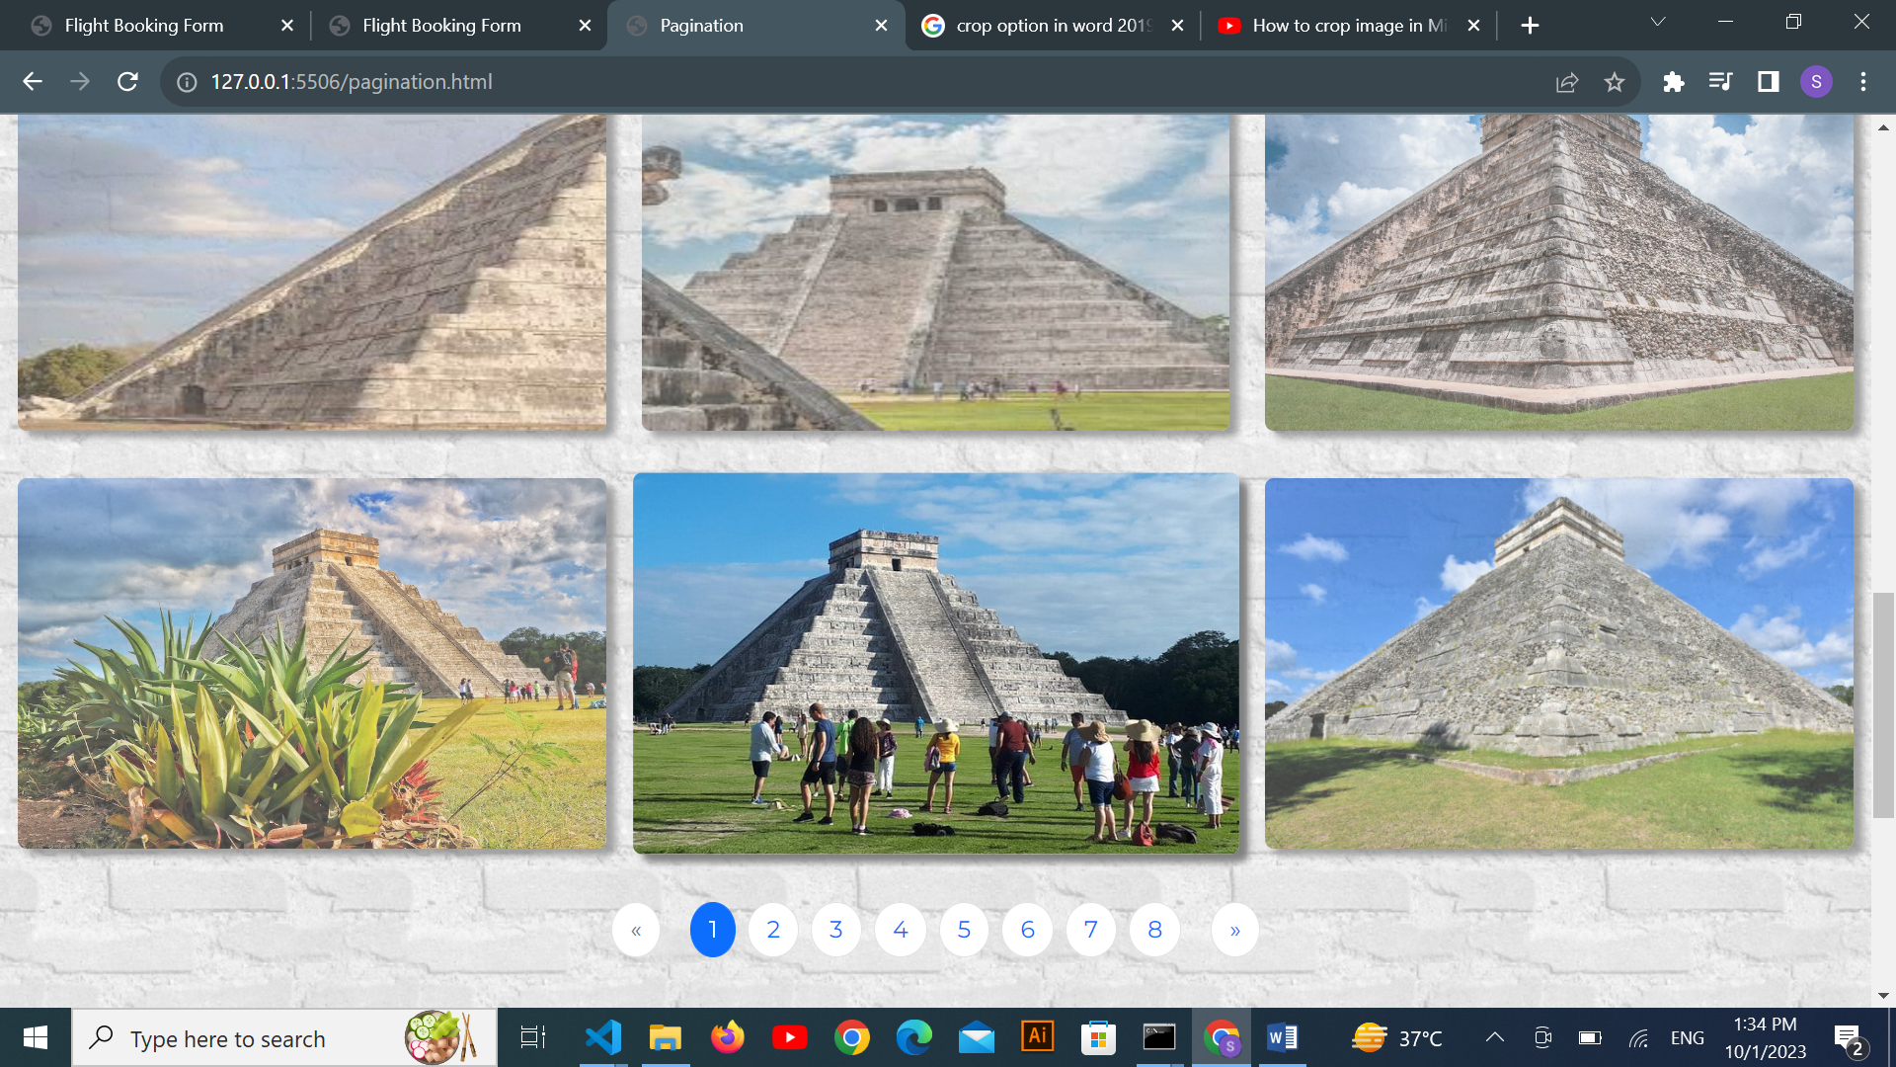

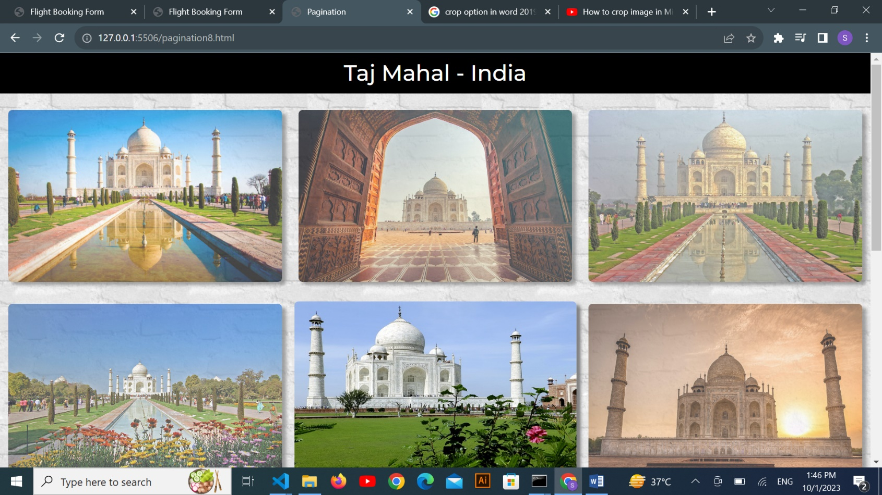

***Figure 5: Gallery***

***Description:***

*In Gallery we have created different pages. This feature allows users to navigate through multiple pages of the gallery content. By clicking the pagination controls, you can easily move forward and backward to explore more images in the gallery. It enhances the user experience by breaking down the content into manageable sections, making it easier to find and view the desired images.*

***6.Our Team (index (1).html):***





*Web Designer and Developer*





*Web Designer and Developer*





*Developer*

1. ***Flight (flight.html):***

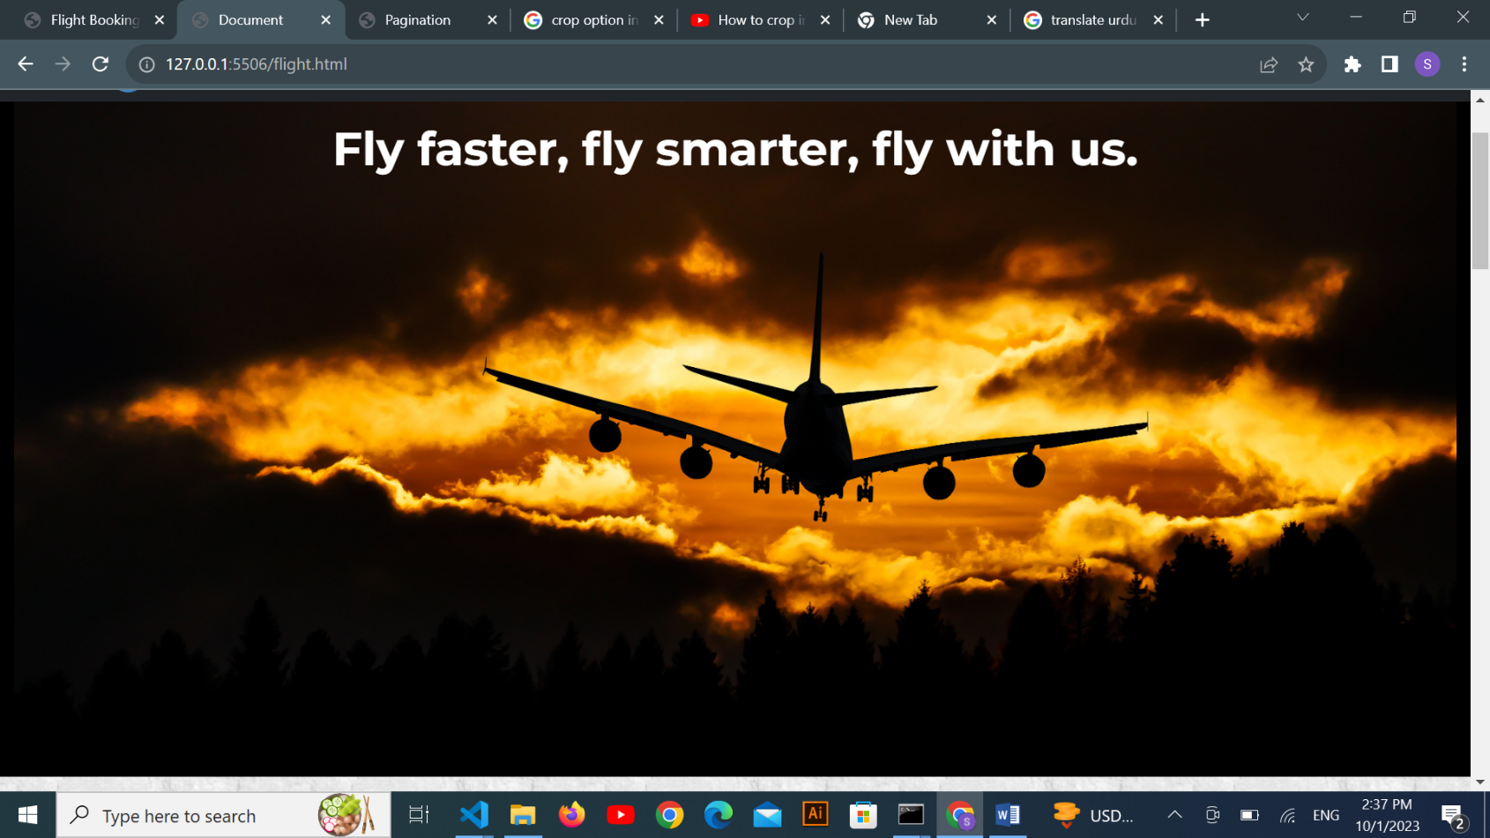

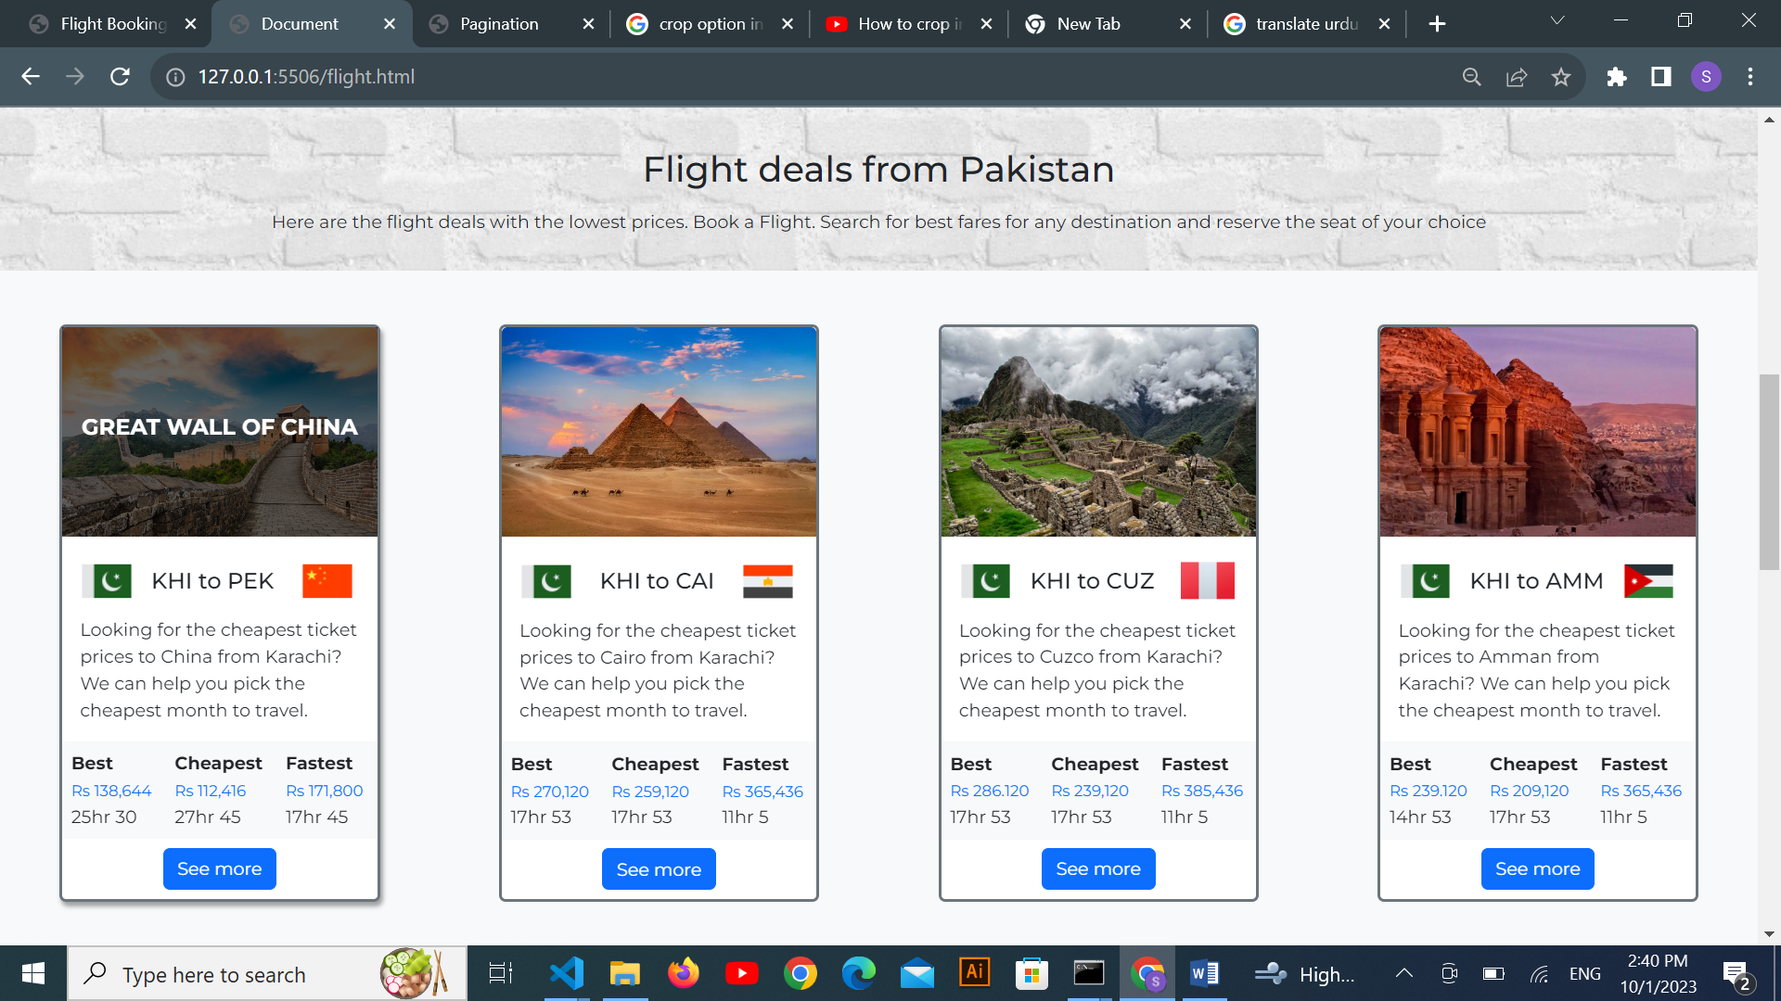

***Description:***

In flight page we have create the best, cheapest, and fastest deals from Pakistan to 7 Wonders of World. You will find competitive prices and option to explore these icon destinations. When you click ‘See more’, a modal window will appear, you can choose the car rental that best suits your needs.

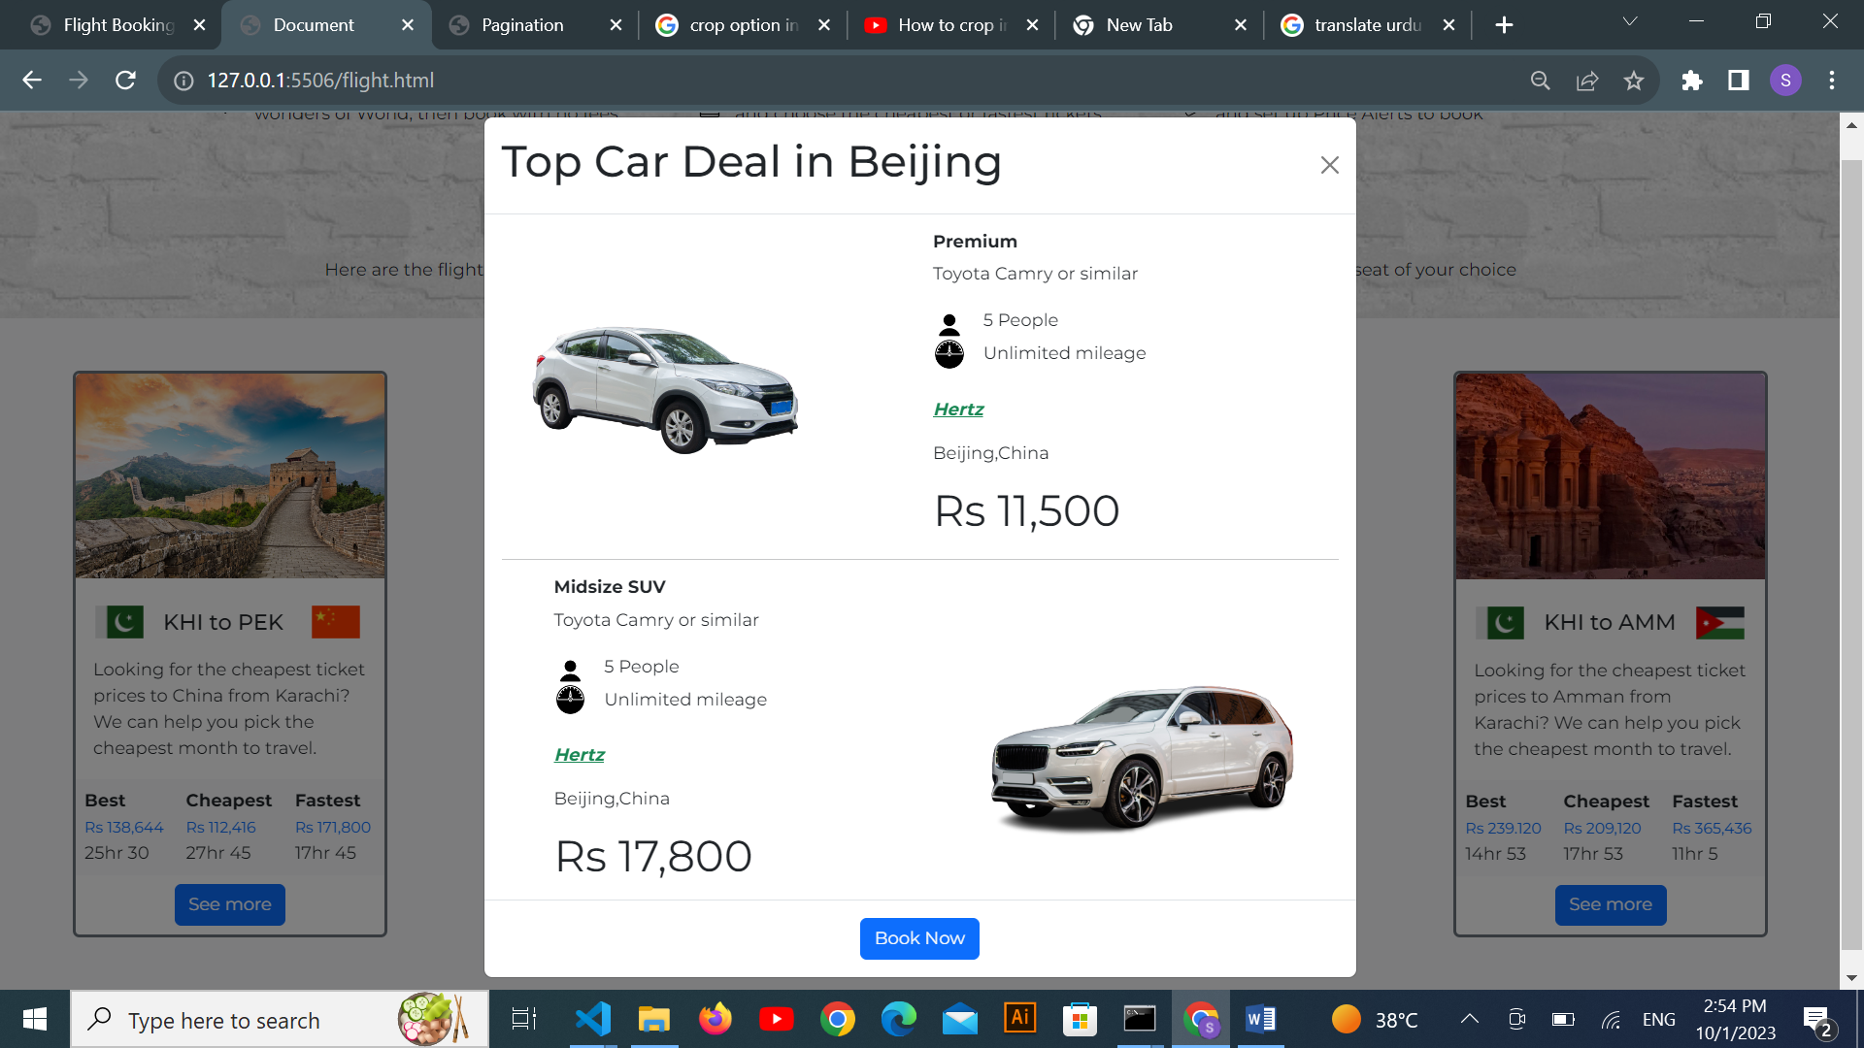

After clicking ‘Book Now’, you will be redirected to a booking form page. To ensure the accuracy and completeness of your booking information, the form is equipped with validation checks. Once all the required information is accurately filled out, you will be able to successfully confirm your tickets. Upon submitting the form. A confirmation alert will be issued. This alert will confirm that your booking request has been received.

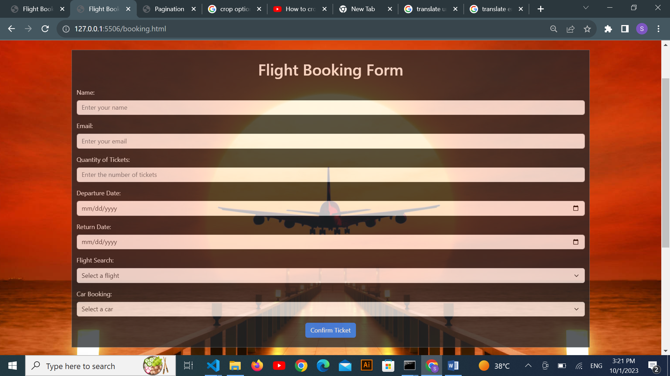

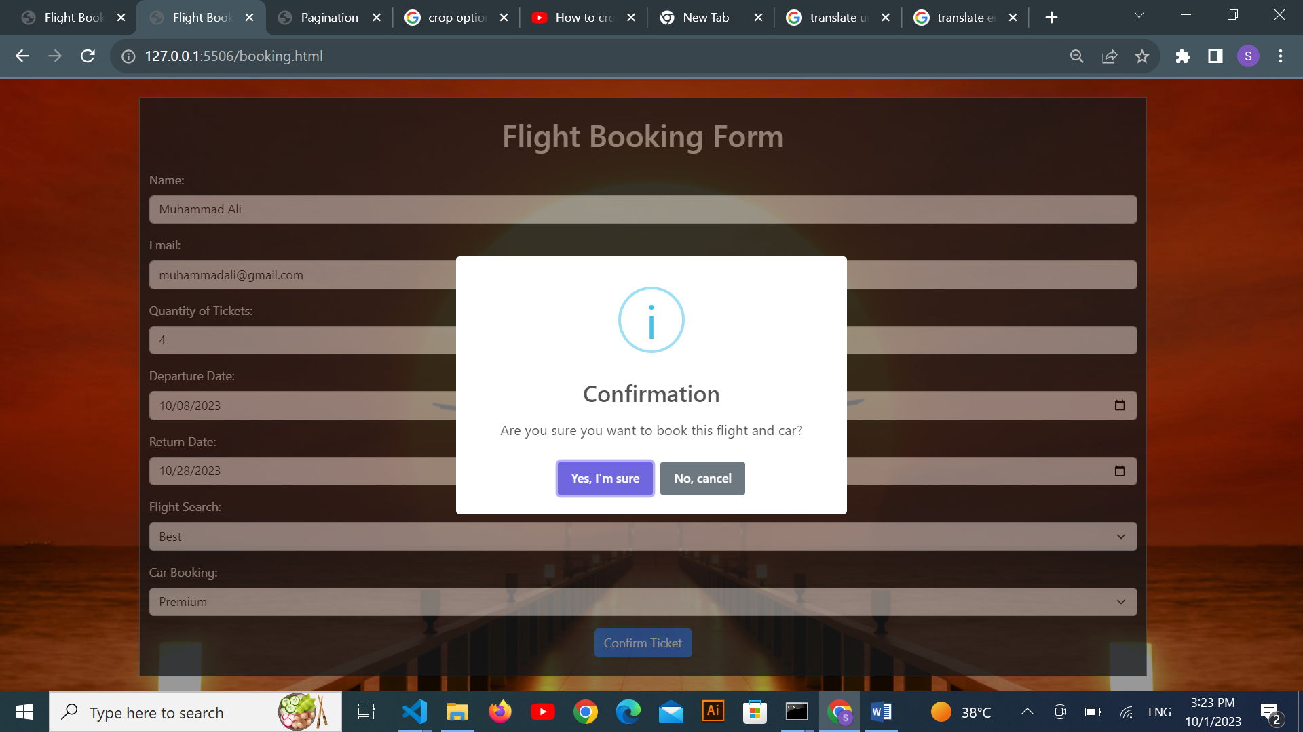

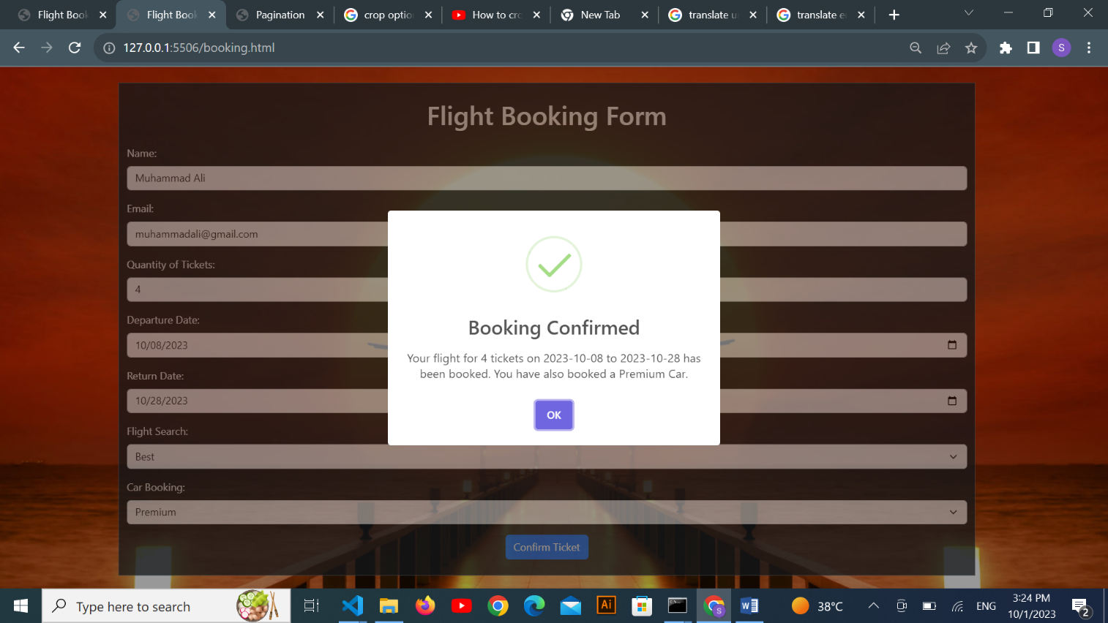

1. ***Most Visited (index.html):***

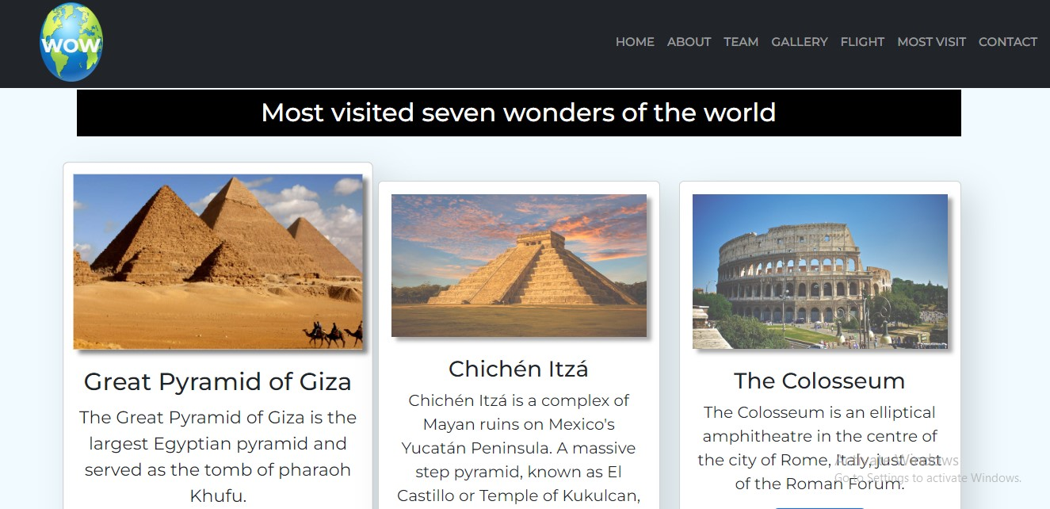

***Figure 8: Most Visit***

*These Seven Wonders of the World continue to captivate travelers from around the globe with their rich histories, architectural grandeur, and cultural significance. Each site offers a unique and unforgettable experience, making them some of the most visited and cherished destinations on the planet. Whether you're exploring the Great Wall of China, gazing at the Taj Mahal, or hiking through the ruins of Machu Picchu, these wonders promise to leave an indelible mark on your heart and mind*

1. ***Questions About Flight (flight.html):***

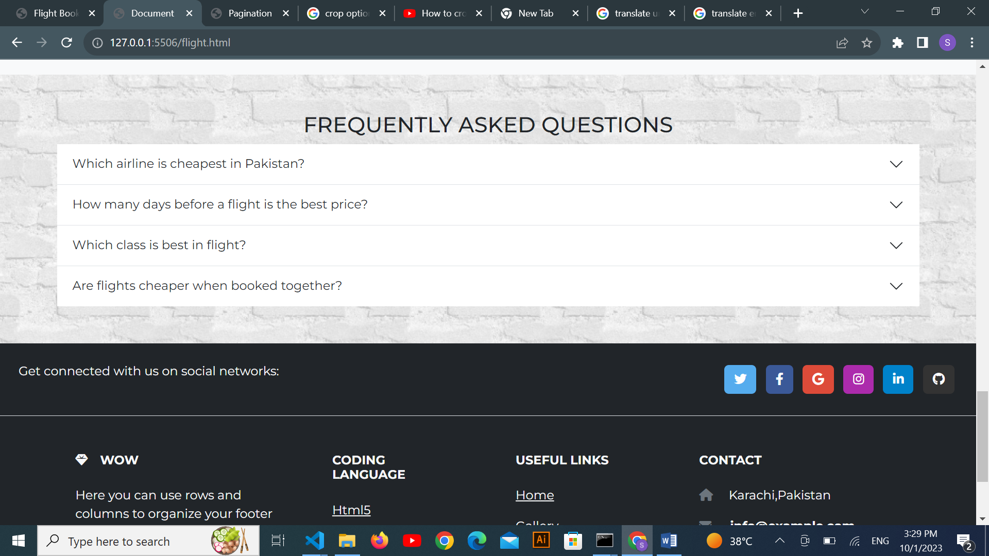

***Figure 12: Questions about Flight***

If any client has any query relates flights so they can have solutions over here.

1. ***Contact (index (1).html):***

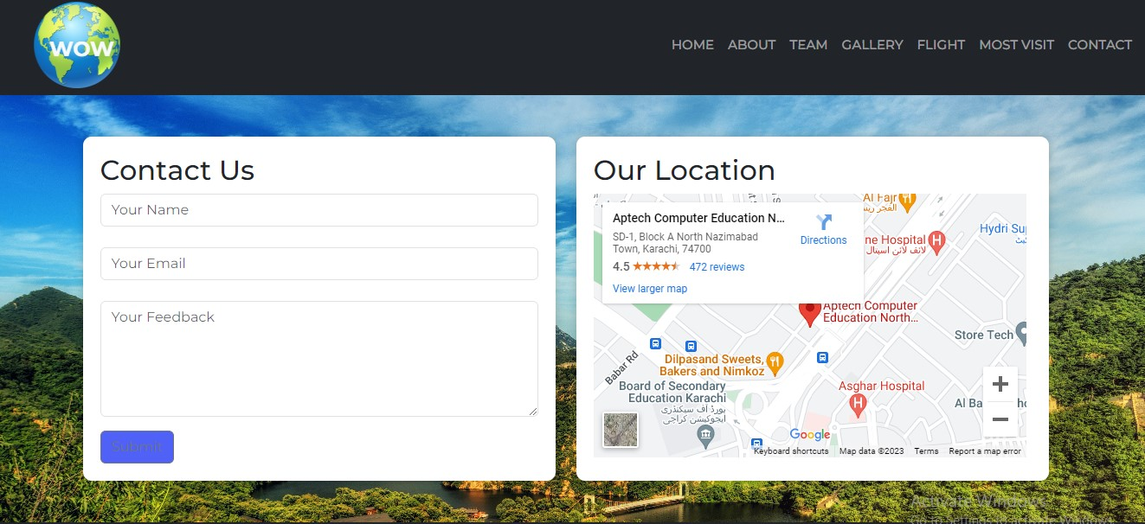

***Figure 10: Contact***

*In our contact section we have given location map for the ease of the people*

*Email id and phone number for contacting in case of any problem.*

*Feedback Form:*

*To know the response of the people our team has given feedback page for the ideas and feedback of the people.*

***Figure 11: Footer***

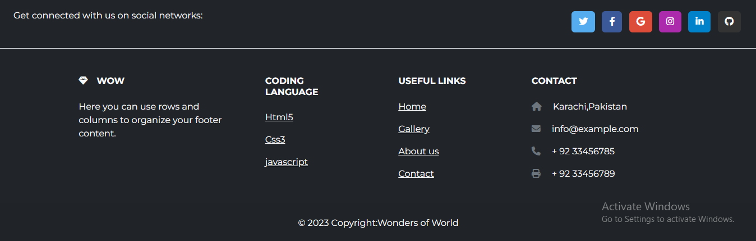 *Copyrights are given in the end of the website and effects of Facebook Instagram and twitter are also mentioned for making the website attractive.*